TITLE OF THE ABSTRACT

A. First¹, B. Second^{1,2}, C. Third²

¹Division of Solid Mechanics, Lund University, Lund, Sweden
²Department of Engineering Mechanics, KTH Royal Institute of Technology, Stockholm, Sweden

The 29th Svenska Mekanikdagarna (Swedish Mechanics Days) is hosted by Lund University and will take place at the Faculty of Engineering (LTH) with the conference dinner being hosted at AF-Borgen in the heart of Lund. We look forward to welcoming you all to Lund on 10-12 June 2026.
Extended abstracts for the 29th Swedish Mechanics Days should be max one page, including title, affiliation, abstract body, and references. Authors are kindly asked to follow this template (available both in Microsoft Word and LaTeX) that demonstrates how to enter typical content such as; figures, tables, equations, and references.
- Extended abstracts must be in English.
- The names and affiliations of ALL authors must be included in the abstract. The name of the presenting author is underlined.
- Start the body text of your extended abstract directly in the affiliation section.
- The two-column body of the abstract can be max. 1 page.
- Use the font of this template (namely Times New Roman 10pt) and set the alignment as justified.
- Do not modify other settings such as margins, line spacing, page setup, etc. used in this guide, simply fill in your title (note that all in capital letters), text, figures, references, etc. in the template.
- The body text must be a single section. Extended abstracts should be in English.
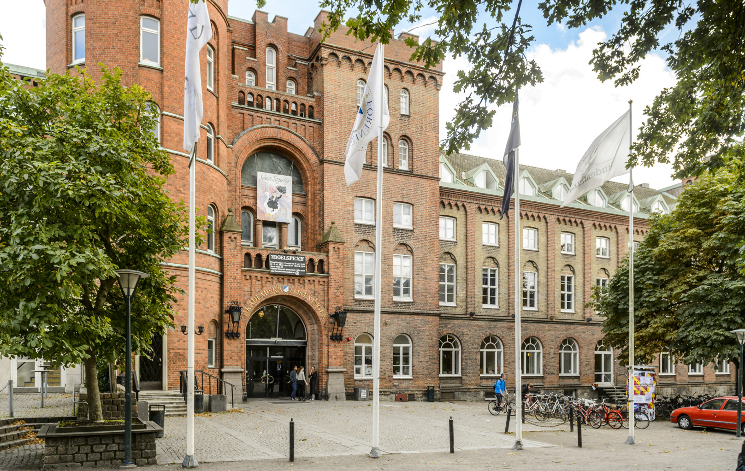
Figure 1: AF-Borgen, site of the conference dinner.
- Number the figures sequentially, according to their appearance in the text, and check that each figure is cited in the text, see Figure 1. Supply a short caption for each figure; more detailed discussion of the figure can be reserved for the text. Figures will be printed in colour.
- The tables should be numbered, captioned, and checked that each table is cited in the text, see table 1.

Date | Time | Place
June 10 | 12:00-17:00 | M-huset, LTH
June 11 | 18:30-21:00 | AF-borgen

Table 1: Preliminary agenda for SMD 2026

- The equations should be indented with the numbers displayed on the right side in parentheses and cited in the body; see Eq. (1).

$\vec{F}=m\vec{a}$ (1)

- The corresponding author's email address should be provided at the end of the abstract's body (bottom of the right column and fit within 1-page limit).
- Make sure that all your references in the reference list are cited in the text.

When ready, save your abstract as PDF and send a single PDF file only to the abstract submission email: smd2026@lth.lu.se, with the title and author list in the body of the email.

We hope to meet you at SMD 2026 in Lund on June 10-12, 2026!

References

- First, A., Second B.C., Third, D., Title of a book (2nd ed.). Publication City: Publisher Press (2015)
- First, A.B., Title of an online-only journal article, Name of an online-only journal, 1, Article 001. Retrieved November 19, 2018, http://www.onlinejournals.com/vol1/art01.html.
- Second, A., Title of a Journal Article. Name of Journal, 1, 123-145, (2012a)
__________________________________________
Corresponding author email: name.x.surname@lth.lu.se

